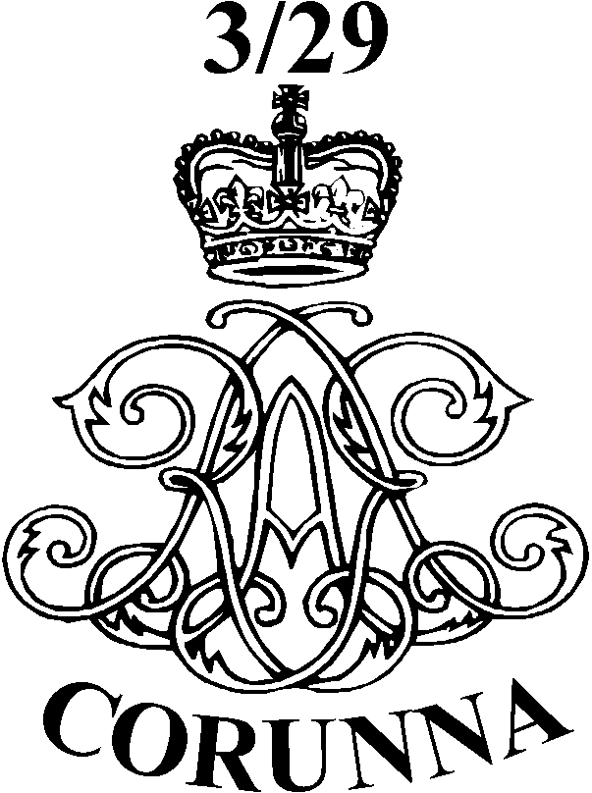
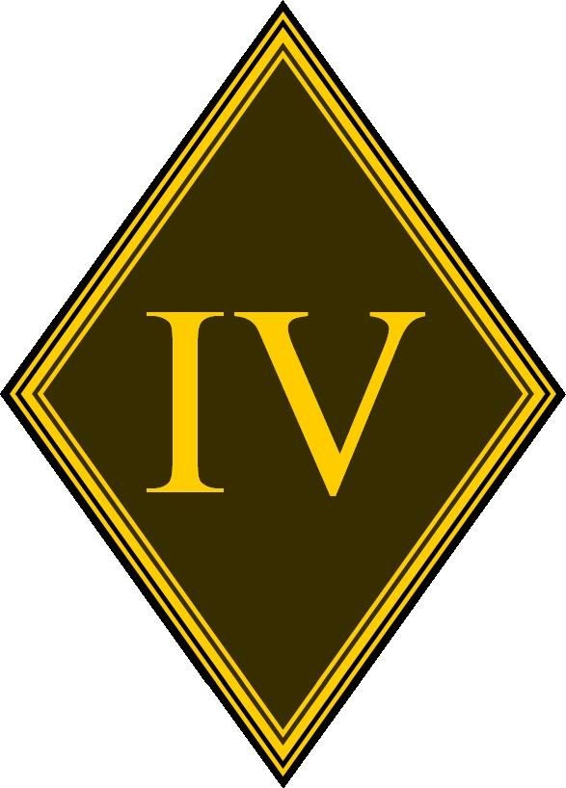
3/29 (CORUNNA) BATTERY
ROYAL ARTILLERY

3 Battery RA was first raised as Chalmer’s Company in 1745. It first saw action in the Austrian War of Succession in 1747 in Flanders. This was followed by service in England, Canada, Scotland, Ireland and in Martinique. In 1877 they took part in the Burma campaign as 33rd Heavy Battery RA and whilst campaigning captured the Myogee Bell, which is on display in the Battery History Room today.
During both world wars the Battery served as a Coastal Defence Battery. The title 3rd Guided Weapons (Field) Battery was taken in 1956 and the Battery served in England and as part of BAOR. From 1967 to 1999, 3rd Light Battery RA saw service in Aden, Northern Ireland and Saudi Arabia as part of OP GRANBY.

29 (Corunna) Battery RA was formed as Hislop’s Company in 1755. The Battery served in India at the siege of Pondicherry (1766) and during the American War of Independence, where it fought at Bunker Hill and York Town in 1771, in the West Indies at the capture of Martinique, St Lucia and Guadeloupe (1794), Trinidad and the Virgin Islands in 1799.
In 1809, commanded by Captain Truscott and armed with 6 pounder guns, the Battery formed part of the rearguard of General Sir John Moore’s Peninsula Army during the retreat to and subsequent battle of Corunna on 16 January 1809. The honouary title of “Corunna” was granted as a result of the Battery’s efforts in this campaign. During the Napoleonic Wars, the Battery was present at the sieges of Antwerp and Mauberg. The Battery next saw action in the Crimean War, during which it fought at Balaclava and at the capture of Sevastopol. There followed 60 years of service in India, much of which was spent on the North-West Frontier.
In 1937 the Battery returned to England and in 1942 it was converted into 2 Airlanding LAA Battery RA, as part of 6 Airborne Division. It was one of the first units to cross the Rhine, for which it was equipped with anti-tank guns and renamed 6 Airlanding Anti-Tank Battery RA. In 1945 the Battery went to Palestine, returning to England in 1948, having regained the title 29 Battery RA in 1947.
Form 1961 to 1965, 29 Battery RA saw action in Malaysia.
Since 1972 several Northern Ireland tours have been conducted and the Battery supported 2nd Battalion the Parachute Regiment during the Falklands War, notably at Darwin and Goose Green. In 1984 the Battery moved to Roberts Barracks, Osnabrück.

On 1st April 1993, 3 and 29 Batteries merged in Osnabrück, inheriting 3 Battery’s Seniority and taking the title 3/29 (Corunna) Battery. 3/29 Battery RA then deployed to Northern Ireland tour in 1994, this time in East Belfast. The Battery deployed to the Former Republic of Yugoslavia (Bosnia) in January 1997. In Feb 1999 the Battery was split up to reinforce 4th Regiment RA prior to deploying to Kosovo, the Regiment returned to Roberts Barracks in Sept 1999 and 3/29 (Corunna) was once again a Battery.
Since returning from KOSOVO, the Battery, deployed to Cyprus (Op TOSCA) in June 2001. The Battery trained for and deployed to Northern Ireland in May 2003 as the Northern Ireland Battalion 4 based in Londonderry. Once the Battery had recovered to Germany it began training for Op TELIC 5 to support the 1 Duke Wellingtons Regiment BG. The Battery deployed to Iraq in Oct 2004 and carried out operations around SE Iraq.
Following this the Battery prepare to deploy on OP TOSCA with the Multi National Mobile Force Reserve. 3/29 Battery RA deploued on OP HERRICK three times between 2007 and 2012.
As part of Army 2020 the Regiment converted to a Light Gun regiment. In 2008 4th Regiment RA moved to Alanbrooke Barracks Topcliffe where it is based to this day.

